

SRI RAMAKRISHNA ENGINEERING COLLEGE
[Educational Service: SNR Sons Charitable Trust]
[Autonomous Institution, Reaccredited by NAAC with ‘A+’ Grade]
[Approved by AICTE and Permanently Affiliated to Anna University, Chennai]
[ISO 9001:2015 Certified and all eligible programmes Accredited by NBA]
VATTAMALAIPALAYAM, N.G.G.O. COLONY POST, COIMBATORE – 641 022.

DEPARTMENT OF COMPUTER SCIENCE AND ENGINEERING
STUDENTS’ CONSOLIDATED FEEDBACK ON FACULTY & CORRECTIVE MEASURES

ACADEMIC YEAR: 2024-2025 SEMESTER: EVEN SEMESTER
Name of the Faculty |  |  | Mrs.M.Indira Priyadharshini,AP/CSE*  Mrs. Amutha surabhi AP/CSE# |  |  |  | Semester |  |  | III
Course Code & Name |  |  | 20CS274 Algorithms and Complexity – I Laboratory |  |  |  | Class |  |  | II
No. of students in the class |  |  | 61 |  |  |  | No. of students offered the feedback |  |  | 51
Parameter | Explanation of course objectives and outcomes | Demonstration on subject matter | Effective communication skills | Arrival of time and availability throughout the session | Covering syllabus and Topics explanation | Usage of teaching aid and technology | Real-world scenarios in critical thinking and problem solving skills | Participation and encouragement in classroom activities | Approachable for questions and offered assistance | Extra efforts to support all students | Timely and constructive feedback on tasks | Provision of  e-resources and other reference materials | Discussion on answer scripts | Course instructor's teaching methodology and approach | Improvement on teaching based on feedback
4 | 24 | 25 | 23 | 26 | 25 | 23 | 25 | 26 | 26 | 25 | 27 | 26 | 26 | 28 | 30
3 | 20 | 18 | 19 | 18 | 17 | 19 | 19 | 15 | 15 | 15 | 16 | 14 | 16 | 14 | 13
2 | 6 | 7 | 8 | 6 | 7 | 8 | 6 | 9 | 9 | 10 | 6 | 9 | 8 | 8 | 7
1 | 1 | 1 | 1 | 1 | 2 | 1 | 1 | 1 | 1 | 1 | 2 | 2 | 1 | 1 | 1
%in 3&4 | 86.3 | 84.3 | 82.4 | 86.3 | 82.4 | 82.4 | 86.3 | 80.4 | 80.4 | 78.4 | 84.3 | 78.4 | 82.4 | 82.4 | 84.3

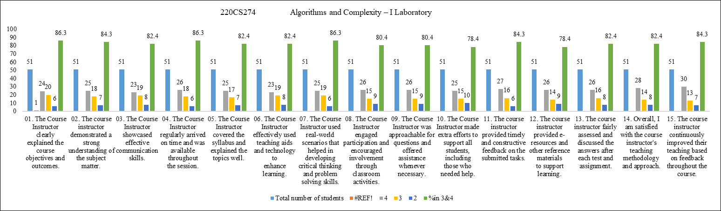
Kind Note:
(i) A target of 75% from the maximum score is being considered for evaluation and attained target of 75% is to
be checked for every parameter.
(OR)
(ii) Corrective measures shall be given for One least score in specified criteria.
Measures planned for improvement
Signature of the Faculty HOD

